**TASK 1: IMPLEMENTATION OF TECHNOLOGY SOLUTION**

Created by Ryan Hildebrant for C768: Technical Communication

**TASK 1: IMPLEMENTATION OF TECHNOLOGY SOLUTION**

Created by Ryan Hildebrant for C768: Technical Communication

**Technical Communication Task 1**

Student Name: Ryan Hildebrant

Student ID: 000709587

Degree Program: Computer Science

Student Mentor Name: Hema Panicker

**Table of Contents**

Cover Page 1

Table of Contents 2

A. Internal Communication Artifact 3

B. Fact Sheet Artifact 4

C. Writing Process for Artifacts 5

i. Overview of Audiences

ii. Planning of Artifact One

iii. Drafting of Artifacts

iv. Planning of Artifact Two

v. Revision and Editing of Artifact One

vi. Revision and Editing of Artifact Two

D. Audience Analysis of Each Artifact 6

**Subject:** Proposal of Network Upgrade to Meet Expanding Interests in Development of an Online Market

**Date:** Tues 23 August 2019 8:43:12 AM

**From:** Ryan Hildebrant <rhilde@sammuscorp.com>

**To:** mmartinez@sammuscorp.com

Dear Mr. Martinez and Executive Committee:

Ms. Thatcher has tasked my department with the design and management of our company’s networking resources. Our job duties require us to ensure that the network and all communication tools are always available to every department in the organization. She has brought to my attention that there is a desire to step into more profitable markets while reducing overhead costs and increasing productivity. Technology-based solutions are growing rapidly throughout our consumer base and innovation is frequent. In order to thrive in this new economic environment, we must create new technologies and implement them on an organizational level. A large portion of this desired advancement is dependent on ensuring that we can maintain the quality of service we have provided to all users in the past. Ms. Thatcher has suggested that we will need to upgrade our internet services to keep up with future growth.

Our current network uses a copper based T1 which can handle a maximum bandwidth rate of 1.544 Mbps and has been in use for the past 18 years. When this network solution was initially installed it provided an abundance of bandwidth to handle our network needs. It is important to note that our T1 is currently responsible for handling all forms of communication in our office including the phone lines, internet, email, storage devices, and the fax machine. As we grow our users will experience very slow response time and calls may be overloaded resulting in a loss of potential business. Switching to a fiber optic solution will prevent this from happening. After thorough research, discussion, and planning with the functional managers of the IT department we have identified a service solution that can scale to the organization’s growth while cutting costs and increasing productivity.

The solution begins with ending our current contract with our ISP provider (Spectrum) and switching over to AT&T. Our team has identified 3 service plans that would fit the requirements of growth we are predicting. These plans all include a flat $12,000 installation rate and a monthly service fee. These service fees also include a monthly fee of $140, $300, or $500 depending on the plan selected.

Additionally, this will ensure that we can handle an increase in calls with a developed VOIP system. Per Ms. Thatcher’s request, our department managers have created a fact sheet that includes necessary planning and diagramming required to make this a smooth transition. If approved, each department has a plan in place to select the required staff and outline the time needed to update our security firewalls and protocols. The entire process will require 90 to 180 days of required transition time with the final date being at the discretion of the ISP, AT&T. I appreciate your combined considerations and look forward to helping Seamus Corporation continue to grow and thrive.

Sincerely,



Ryan Hildebrant (rhilde@sammuscorp.com)

Operations and Networking Manager

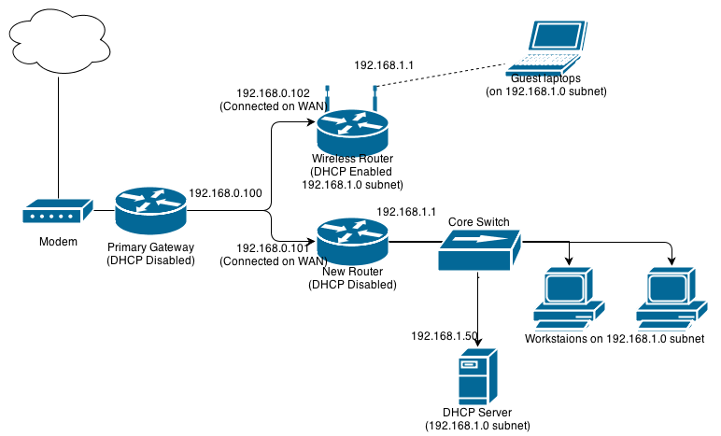

**What is a Fiber Network?**

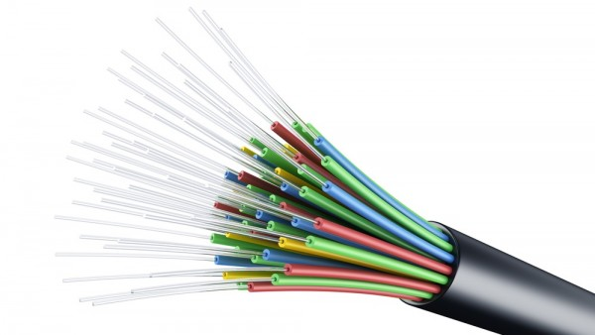

Fiber-optic networks transmit information using a process that sends pulses of light through an optical fiber cable. This type of technology allows for signals to be sent a longer distance than traditional copper-based solutions. This technology also allows for our organization to have much faster network speeds.

**Why should we implement a Fiber-Optic network?**



Sammus Corporation takes great pride in the learning resources we provide. Our students are increasingly becoming more involved with the internet and we must adapt our services to fit their needs. Creating a network fit for this adaptation will help our organization continue to grow.

**Network Upgrade**

"Fiber-optic communication optical fibers have largely replaced copper wire communications in core networks in the developed world. The process of communicating using fiber-optics"

*Source: Optical fiber network -* [*https://en.wikipedia.org*](https://en.wikipedia.org/wiki/special:search/Optical%20fiber%20network)

Phase 1: Executive management will select the service package and begin the drafting phase. Network service managers will compile a list of static IP addresses and gateways (shown above).

Phase 2: Functional managers from the required departments (security, networking, service desk, deployment, and HR) will assign employees to begin migrating each department.

Phase 3: ISP will come in on September 3rd and install lightbox and new fiber capable switch in the network room. Initial network testing will also occur during this phase. Once testing is complete, we will create an intranet using the fiber network and present it for sign-off. During this period the service desk will also receive an updated training manual and spend 3 hours learning troubleshooting training.

Phase 4: After hours of operation the network team will begin full migration to the fiber optic network. This will cause an estimated service interruption period of 6 hours.

Phase 5: During the 2 weeks following phase 4 network employees will closely monitor network resources and ensure the network is working as intended. After this period is complete all employees will return to standard operations.

**Summary of Required Phases**

**Description of Writing Processes for Artifacts (Planning, Drafting, Revision & Editing)**

**Overview of Audiences**

All information pertaining to the selected artifacts will be shared with either (1) executive leadership of the organization or (2) relevant cross-functional teams. Executive leadership comprises of key stakeholders including the CIO, CFO, and upper management. This includes any functional managers that are involved in the networking and security departments. They should be updated of any milestones, complications, or necessary changes. Additionally, the CIO will be labeled as the project sponsor and will provide final sign off for all milestone completions. Cross-functional teams will be all necessary members of the IT team who will be implementing and providing feedback for the completion of the network upgrade. This team will be compromised of selected members of the following 5 sub-IT groups: security, networking, service desk, deployment, and HR. Their feedback and tools will be critical to the successful execution and management of a fiber optic network. I created this wide range of audiences so I could demonstrate the many different types of people in an organization.

**Writing Processes Analysis for Previously Described Artifacts**

* **Planning of Artifact One (Internal Communication)** involves analyzing the reader’s needs, purposes, and writing situations. These elements will also aid with gathering the needed information and organizing the data to fit a communication atmosphere that will appeal to the required stakeholders. I created this email to show that not all stakeholders involved will have the technical knowledge required to understand the procedures for moving the network. To better fit their needs, I designed the document to fit their needs rather than focus on technical language. Additionally, I thought it was important to create a document based on a suggestion from an executive. I felt that this was the best approach to seek approval from the entire audience.
* **Drafting of Artifacts** was focused on taking the scenario I created in the planning phase and condensing it to fit my reader’s needs. The drafting phase turned out to be a very important step for me because it made me realize that the initial drafts were missing information that I would consider vital for an executive team. This required condensing the document while also adding more information related to the cost and organization wide benefit.
* **Planning of Artifact Two (Procedural Fact Sheet)** is kickstarted after I decided the purpose of the fact sheet. I identified that I would be addressing 5 sub-departments and needed to set a baseline of knowledge level. I wanted to create a document that clearly outlined why we are doing this and how it could be done. This required me organizing the document to show that transparency. The fact sheet was also designed to inform and instructor all parties.
* **Revision and Editing of Artifact One (Internal Communication)** is focused on content and organization. I needed to reduce the content to fit in a short email that provided enough information that was relevant to the readers. The document needed to also be organized in a way that gave the readers an easy decision to make.
* **Revision and Editing of Artifact Two (Procedural Fact Sheet)** had different goals in mind. The focus of this document was primarily on language and graphic aids. I had to reduce the scope of my explanations to make it easier to define the required networking terms without using an abundance of jargon. I also wanted to include a graphic aid that showed a top-level view of the change but did not take up the entire document. I thought this was important because not all users involved needed to have the network diagram, but it was a critical feature of the network upgrade.

**Audience Analysis of Each Artifact**

**Artifact 1: Email to Executives**

Artifact 1 addresses the first audience which is comprised of the CEO, Mr. Martinez, and his executive team. Mr. Martinez is educated in business and finance and has worked in the publishing business his entire life. His knowledge of IT is limited. This audience is positive, eccentric, and very passionate about the growth of their organization. They will respond well to any initiatives brought forth that can grow the company through means of IT.

* **Subject knowledge -** His technical background is not strong, and he does not have any understanding of how the network operates. My document is primarily tailored to him by outlining what a network is and why it needs to be upgraded. I try to keep out as many technical details as possible to not complicate his understanding.
* **Position in the organization –** The CEO is the most superior position in the organization, and it is ultimately up to him to decide if the proposal will be put into action. The document is tailored to fit his level of understanding and encourage him to move forward with a decision. The readers need to be persuaded that this is a must.
* **Personal attitudes –** I know that the executive team is highly motivated by change and expansion. I keep a positive feeling throughout to appeal to these emotions and motivate them to become eager to act.
* **Reading styles –** Given that my goal of this document is to persuade readers to act I wrote the document with the intention that readers will study the entire document. I want to give the CEO a clear scope of the change process and make sure all readers understand it as a positive change.
* **Types of readers –** The primary reader is the CEO and the secondary readers are the executives. Because Mr. Martinez is the one who will ultimately make the decision, I write the document to fit his understanding and avoid overbearing technical language.

**Artifact 2: Fact Sheet for Functional Managers and Peers**

Artifact 2 is a fact sheet that is designed for the entire IT department who is involved with the operation. I designed the document to show collaboration from the functional managers to fit all of audience 2.

* **Subject knowledge -** Given the board scope of sub-IT functions that are involved with the network transition process I created the document to address the lowest level of subject knowledge. These individuals use the network every day for their varying business functions and I can classic the whole group as semi-experts.
* **Position in the organization –** The functional managers hold the most authority in the group. However, the document addressed to peers so that members of the team can use the document as a reference for inter-departmental communication.
* **Personal attitudes –** This fact sheet is written to fit the preferences of all sub-parties involved. There is valuable information for each individual and I try to keep any emotion out of this objective document
* **Reading styles -** This fact sheet is addressed to imply that the readers are secondary readers in nature. The purpose of this document is to give them the facts needed for their job function.
* **Types of readers -** The document is designed to have readers check for specific sections of information. The left-hand side should be understood by all readers while the phases are more specific to each group.